**NOMINA**

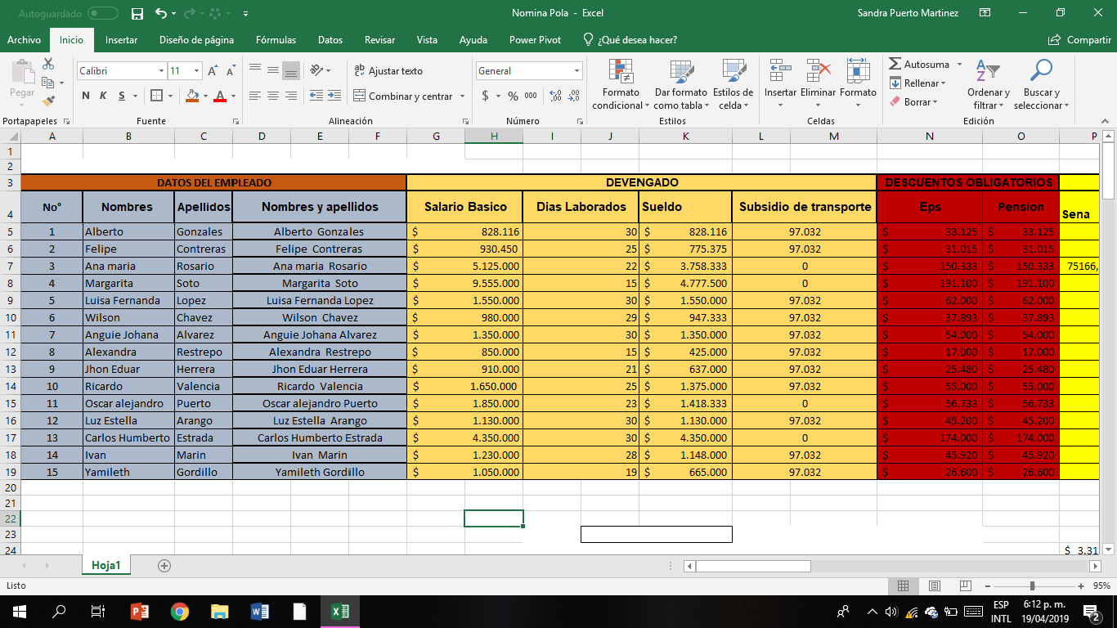

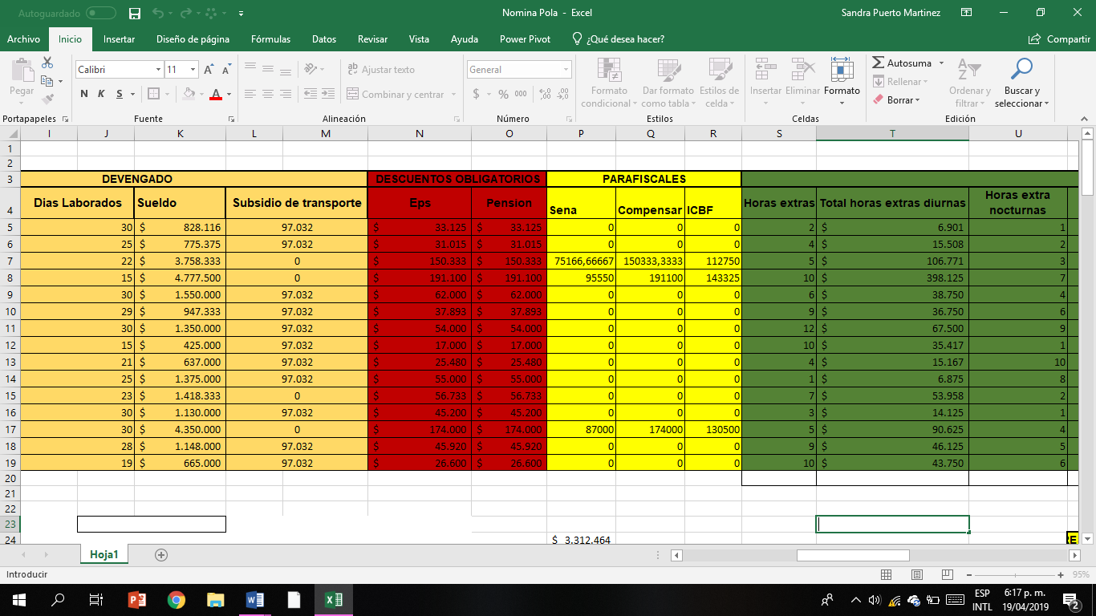

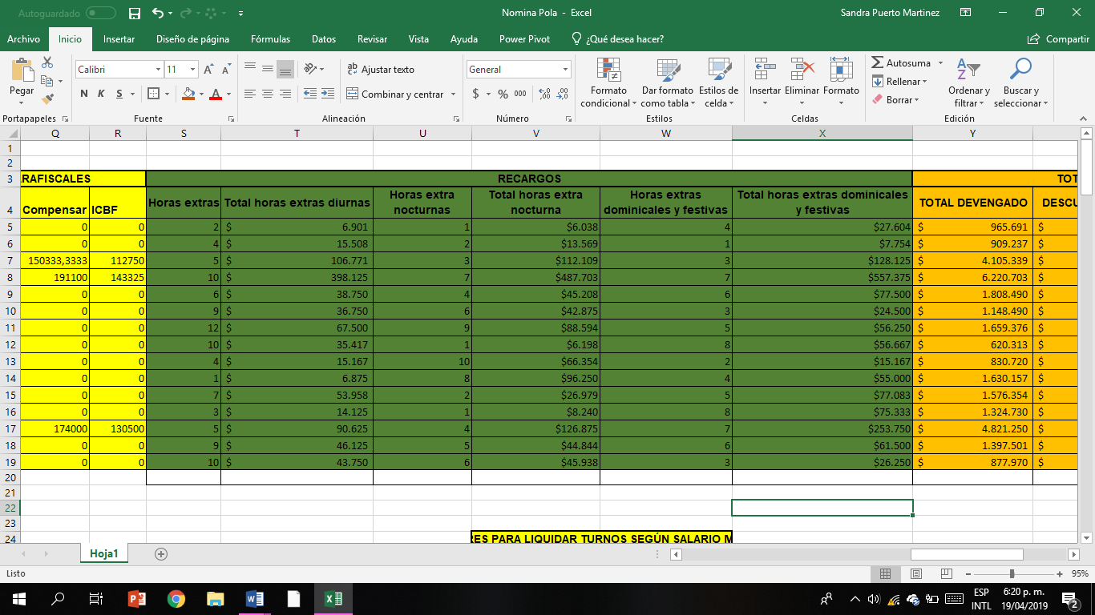

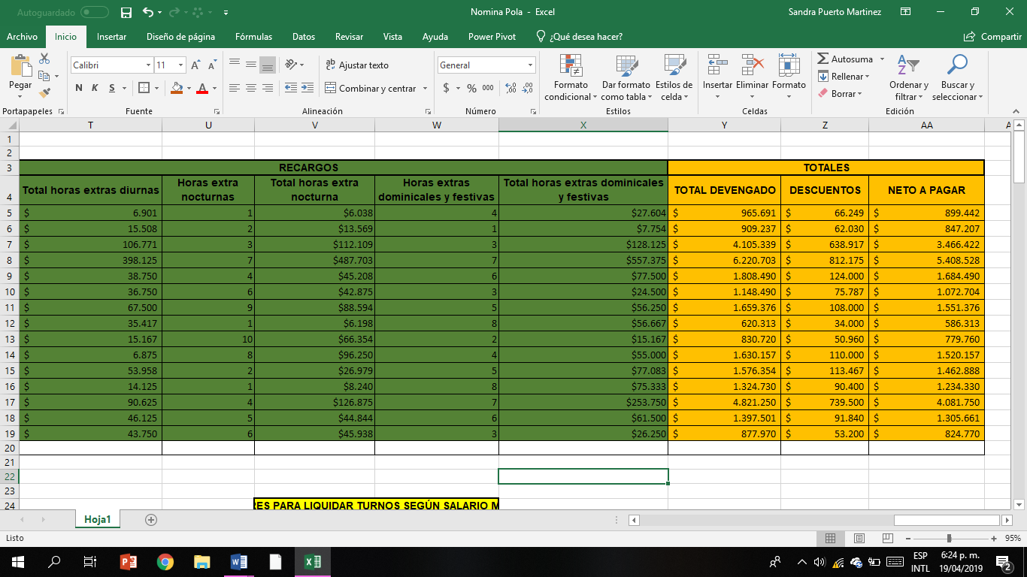

<https://drive.google.com/open?id=1k71whV85AiuPx8f8E8mUY0cJg1peujUN>

<https://drive.google.com/open?id=1SeMFilOU9n3OQ66VzN7N35xrROjF0Xjs>